ISE-309

HW-1

Selin Dinç

150150229

In the first part of the code, I read all the images and padded the image boundaries by zero. I found the pad width by using pad_width=(kernel-1)/2. After that, I put all of the padded original images in separate lists. Then, I created the kernels.

I created new images which are going to show the filtered images. Then, padded them with zero. I created separate lists for each pad size.

In my code, all the filtering process is made by one function which called OperationFunc. In this function, I’m applying each filter to each image by iterating through the images.

1. In the first question, I applied Mean filter with the sizes; 3x3, 5x5, 7x7 and 11x11 to blur each image as we see in the images;

3x3 Image1

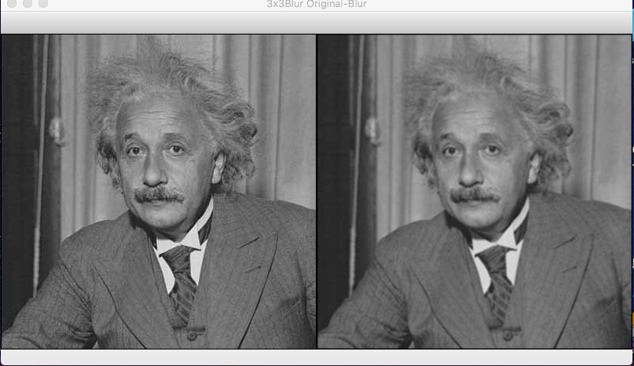

3x3 Image2

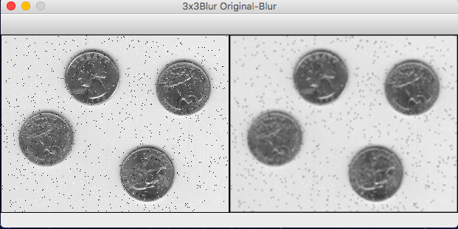

3x3 Image3

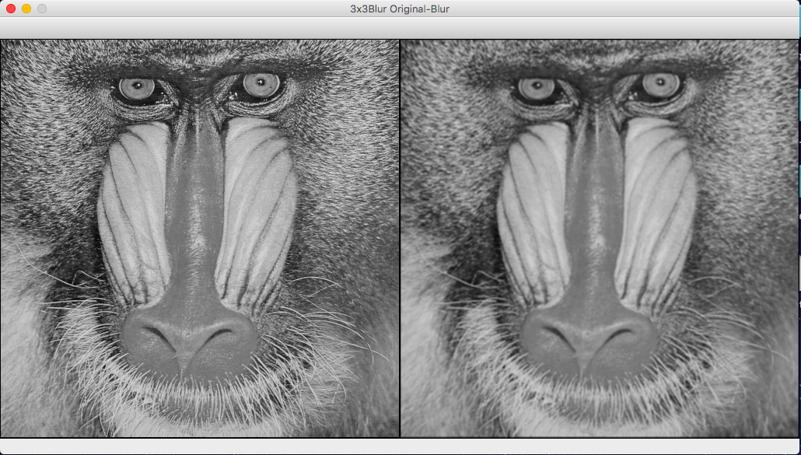

3x3 Image4

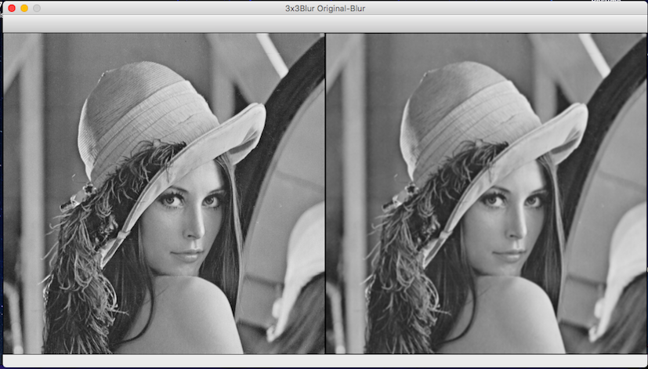

3x3 Image5

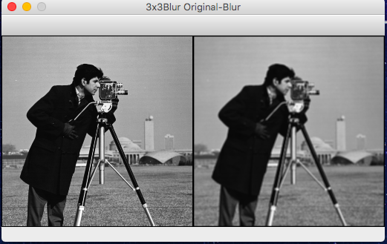

5x5 Image1

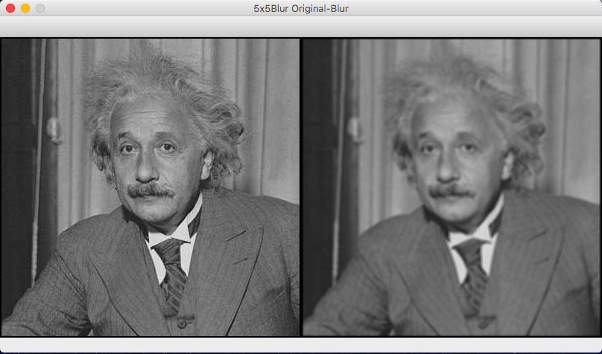

5x5 Image2

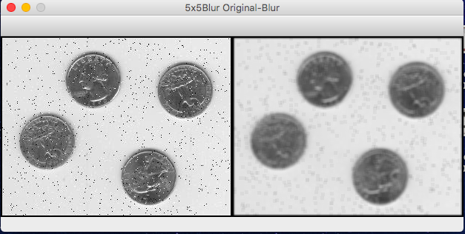

5x5 Image3

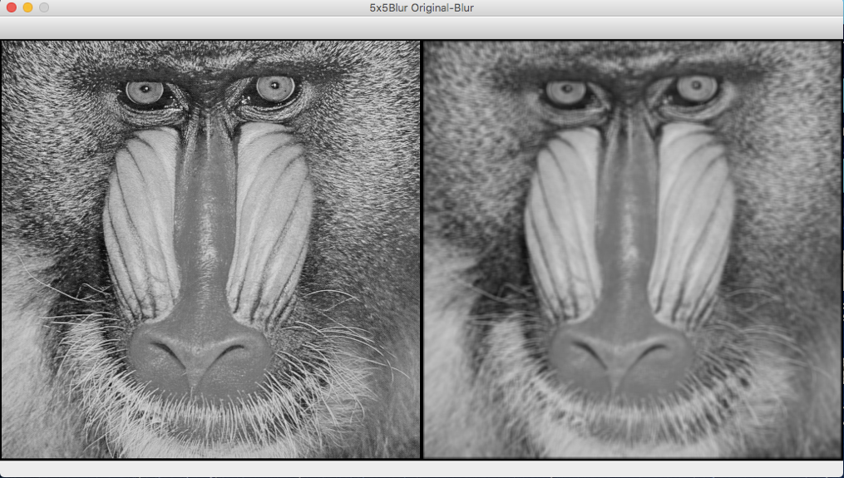

5x5 Image4

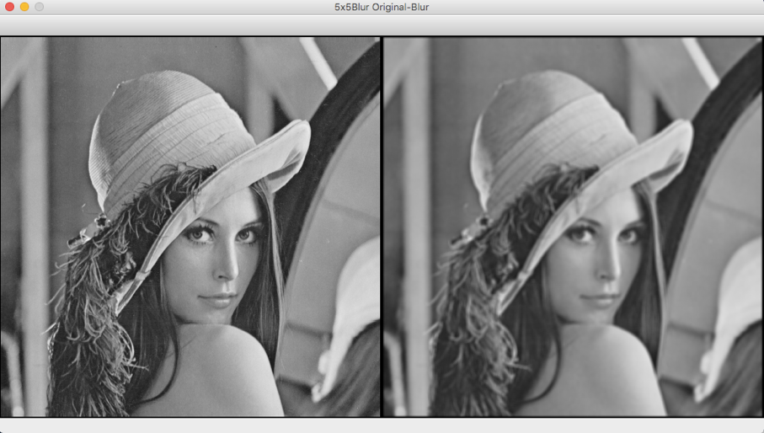

5x5 Image5

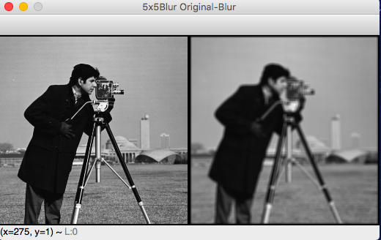

7x7 Image1

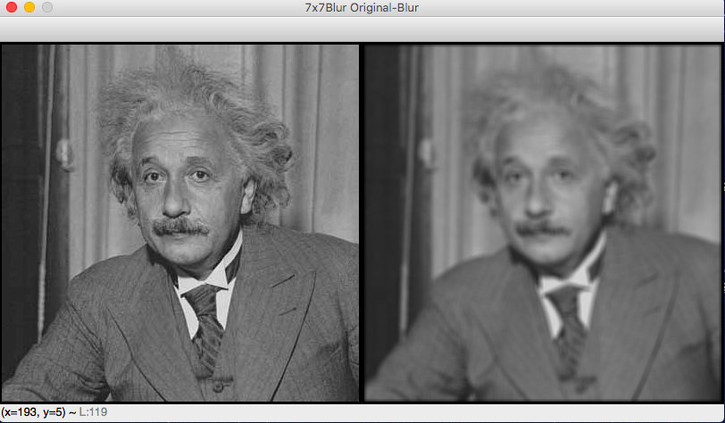

7x7 Image2

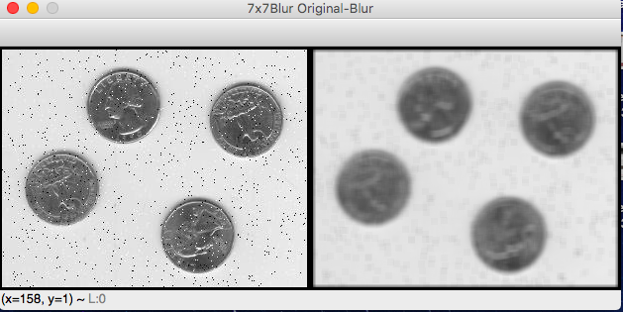

7x7 Image3

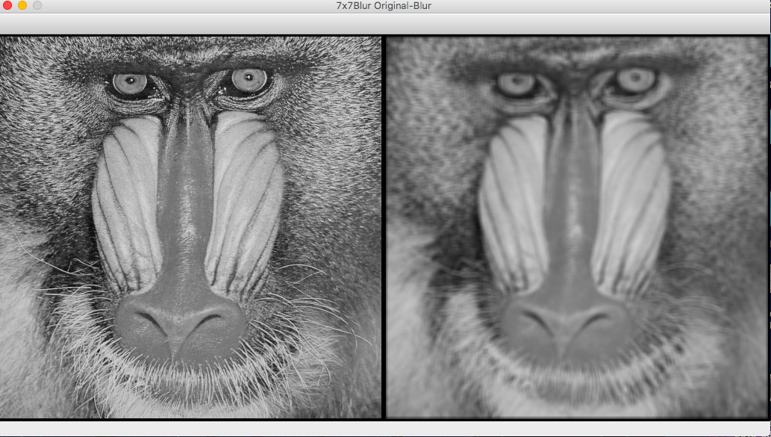

7x7 Image4

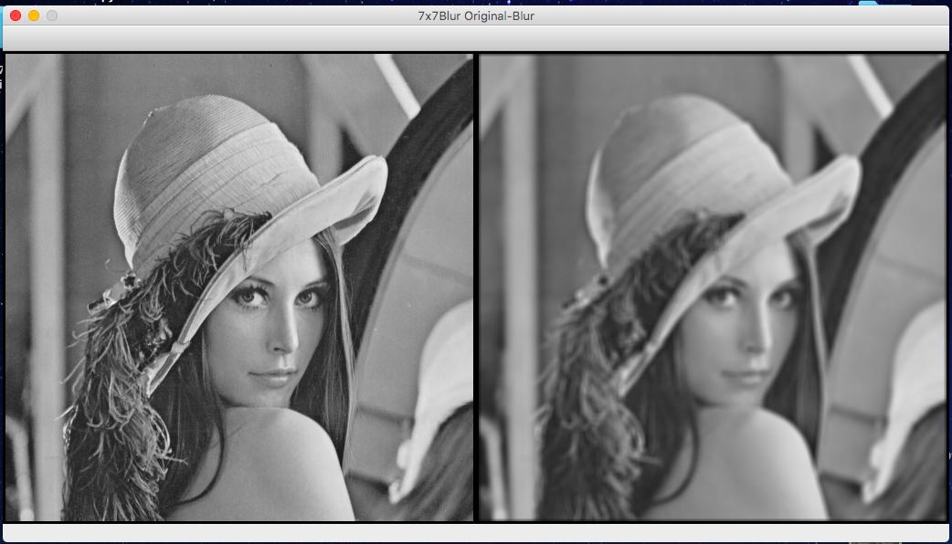

7x7 Image5

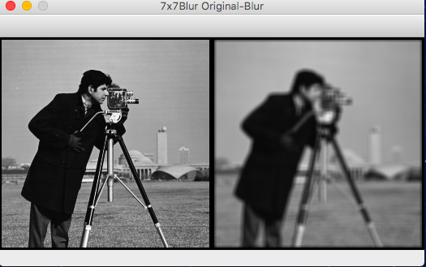

11x11 Image1

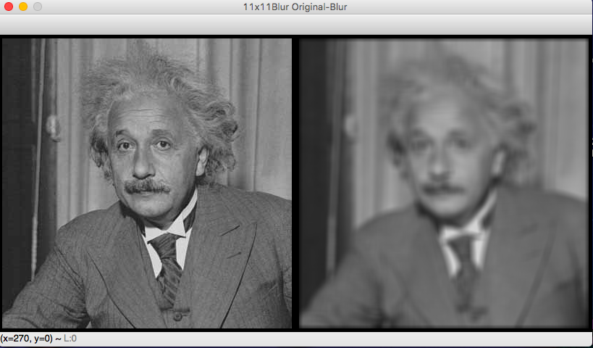

11x11 Image2

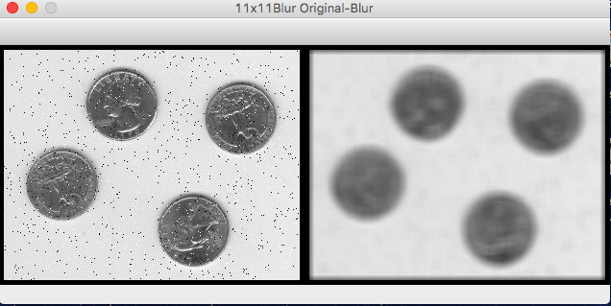

11x11 Image3

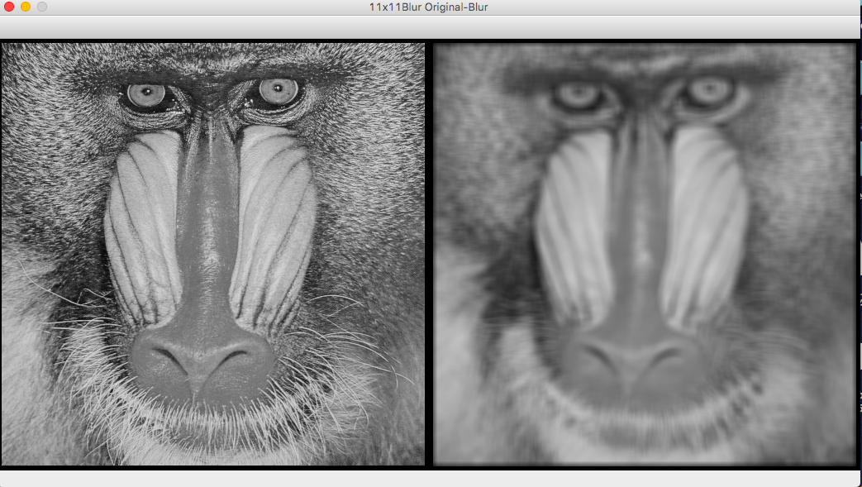

11x11 Image4

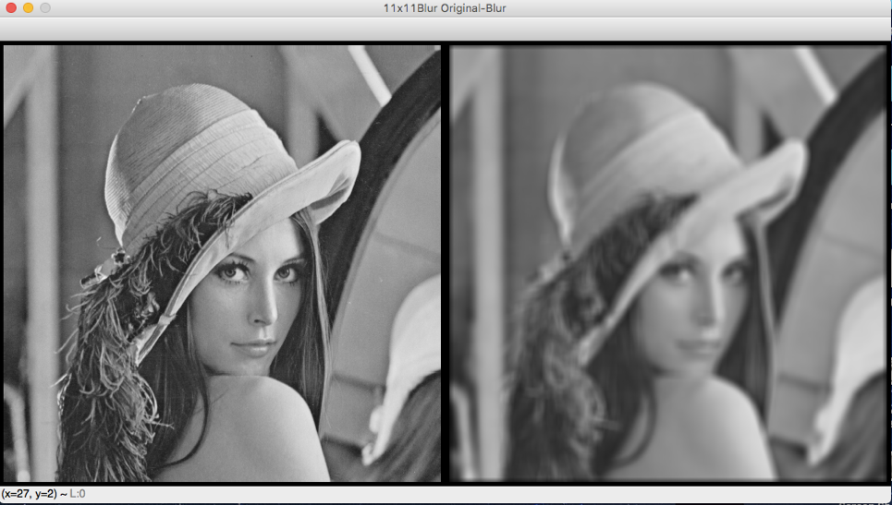

11x11 Image5

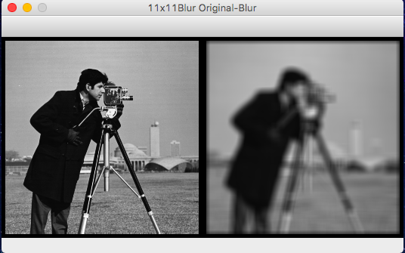

1. In this question, I subtracted the blurred images from the original images.

3x3 Subtracted Image1

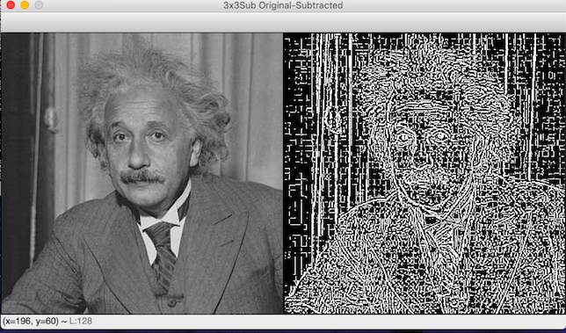

3x3 Subtracted Image2

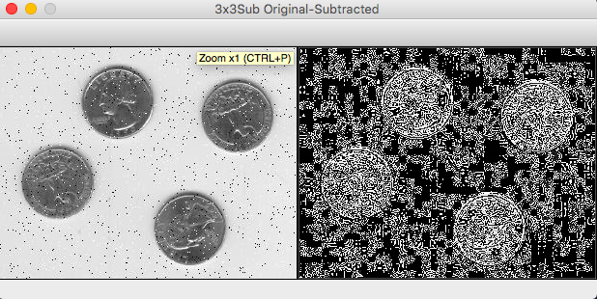

3x3 Subtracted Image3

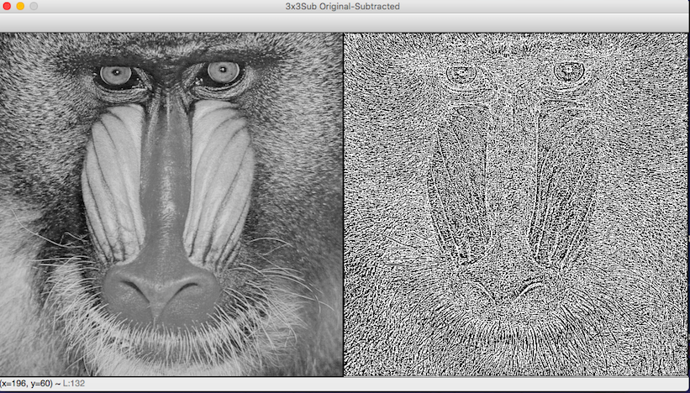

3x3 Subtracted Image4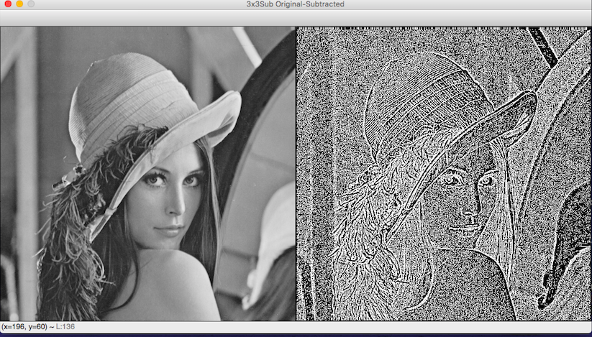

3x3 Subtracted Image5

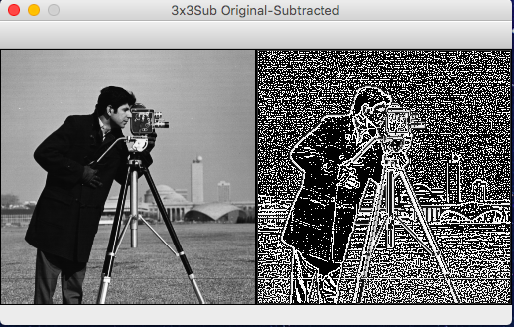

5x5 Subtracted Image1

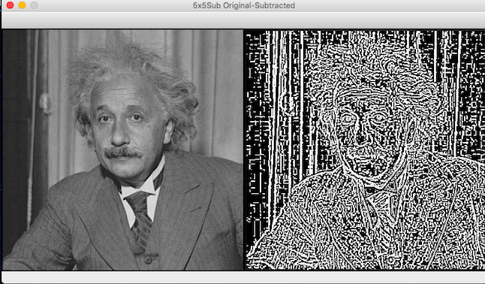

5x5 Subtracted Image2

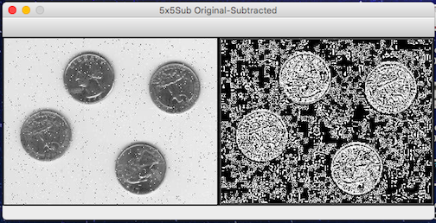

5x5 Subtracted Image3

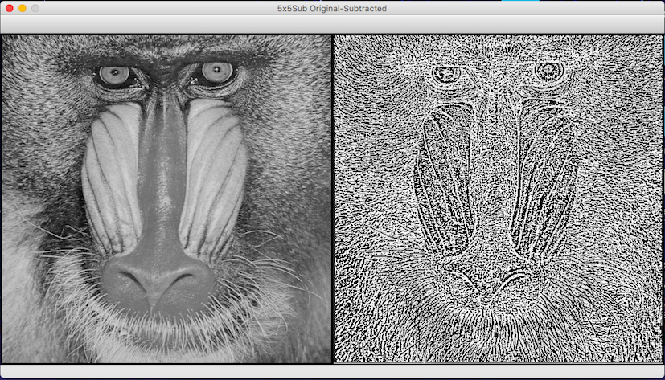

5x5 Subtracted Image4

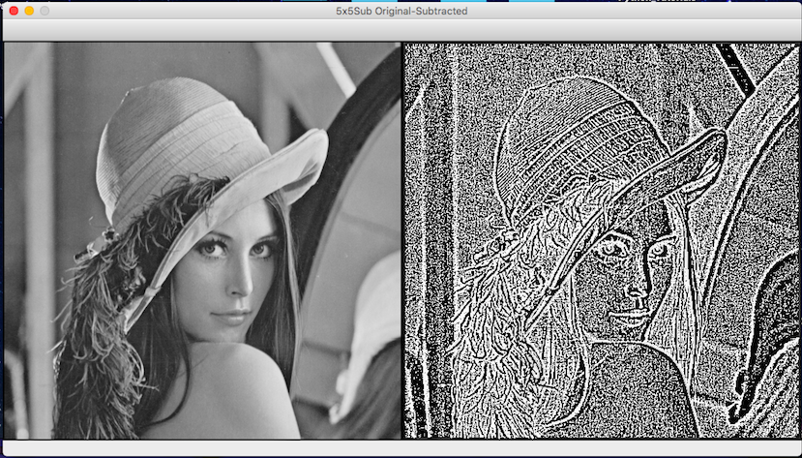

5x5 Subtracted Image5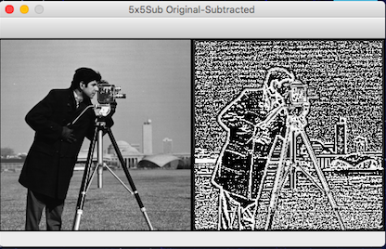

7x7 Subtracted Image1

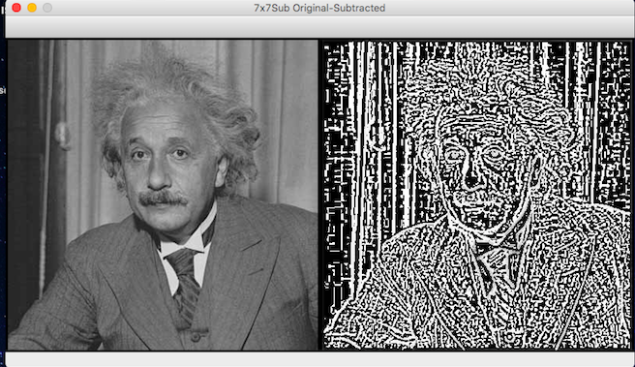

7x7 Subtracted Image2

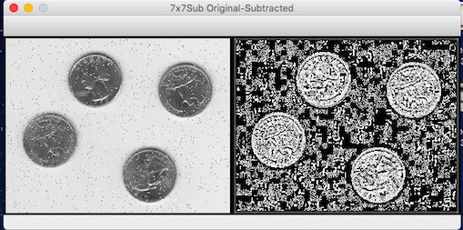

7x7 Subtracted Image3

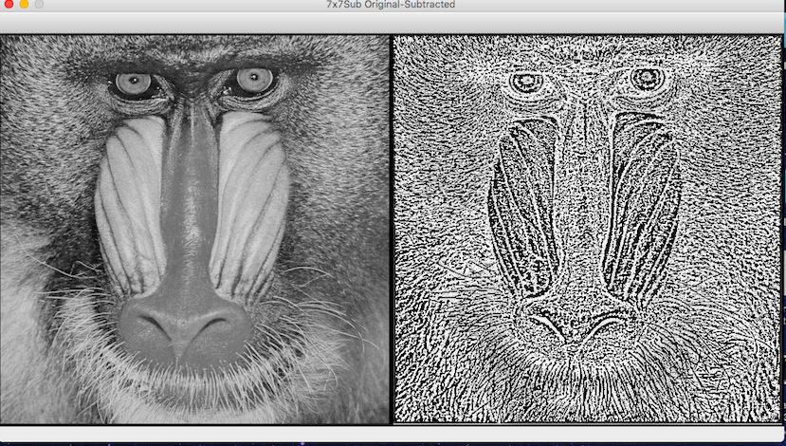

7x7 Subtracted Image4

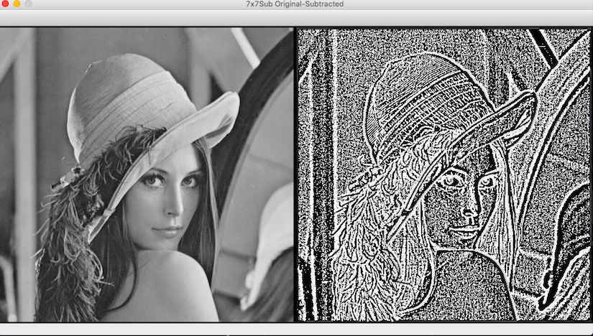

7x7 Subtracted Image5

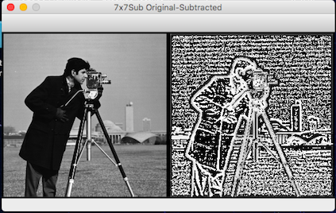

11x11 Subtracted Image1

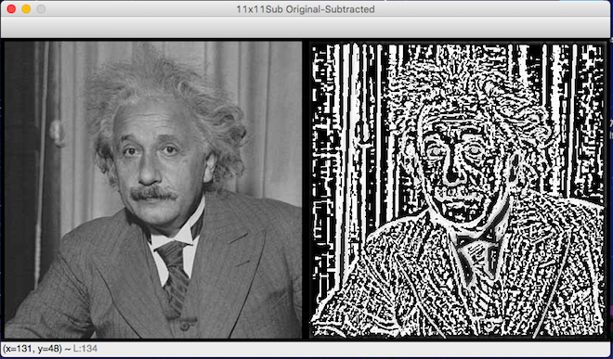

11x11 Subtracted Image2

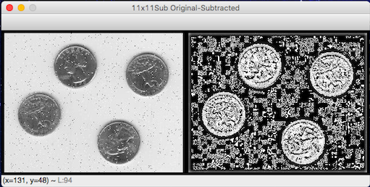

11x11 Subtracted Image3

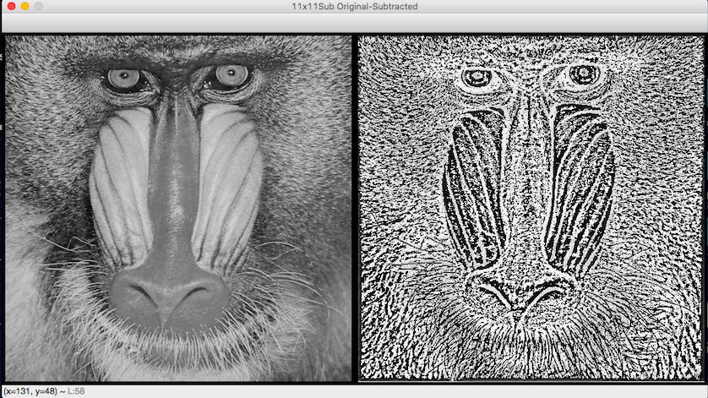

11x11 Subtracted Image4

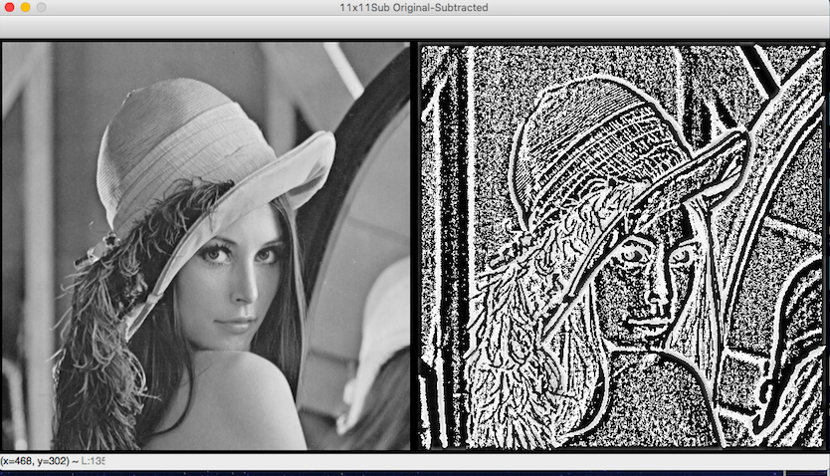

11x11 Subtracted Image5

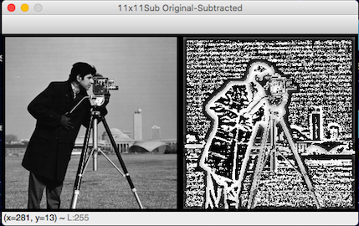

1. In this question, I shifted the images 2 pixels up and 3 pixels right.

Up Image1

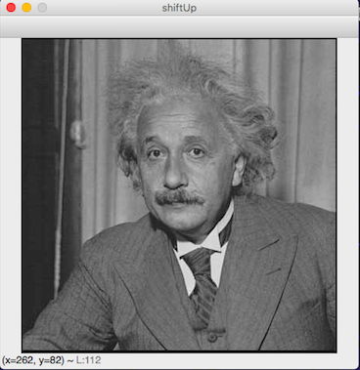

Up Image2

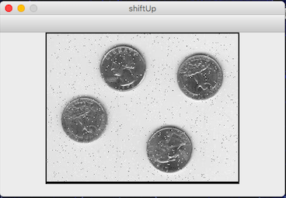

Up Image3

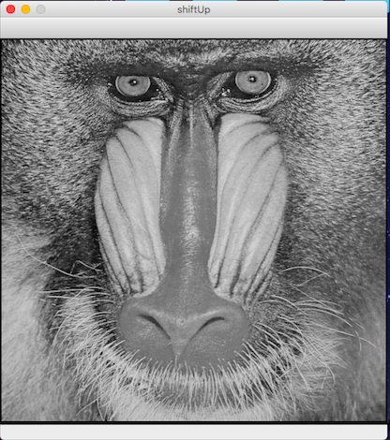

Up Image4

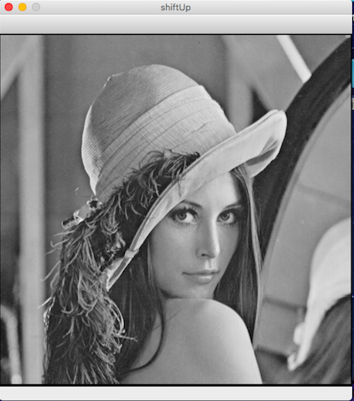

Up Image5

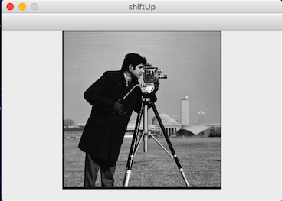

Right Image1

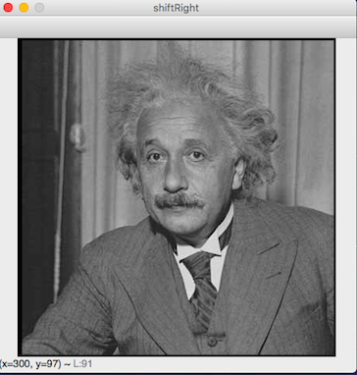

Right Image2

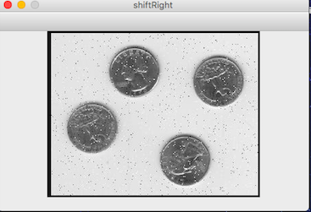

Right Image3

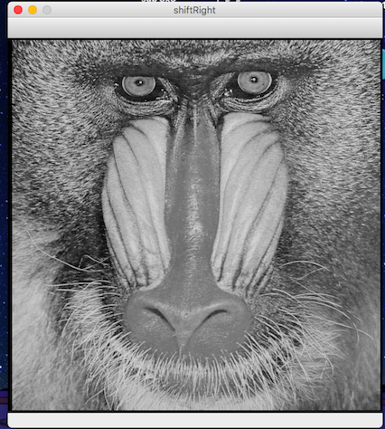

Right Image4

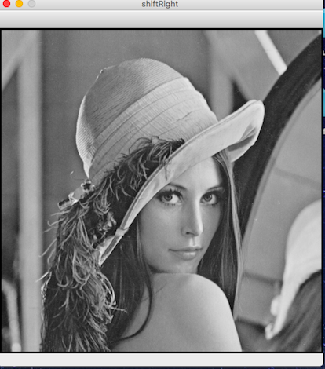

Right Image5

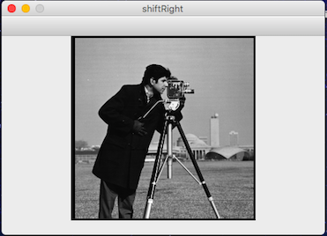

1. In this question, I sharpened the images by using 3x3 sharpening filter.

Sharp Image1

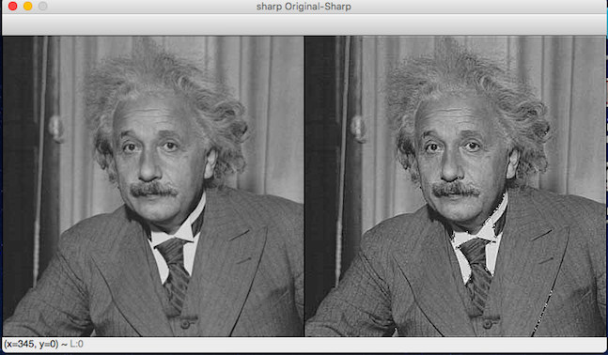

Sharp Image2

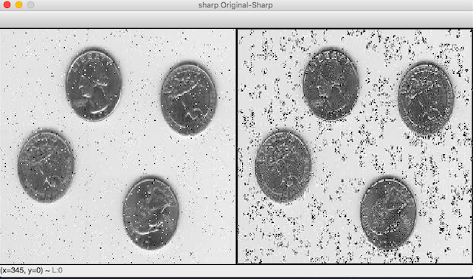

Sharp Image3

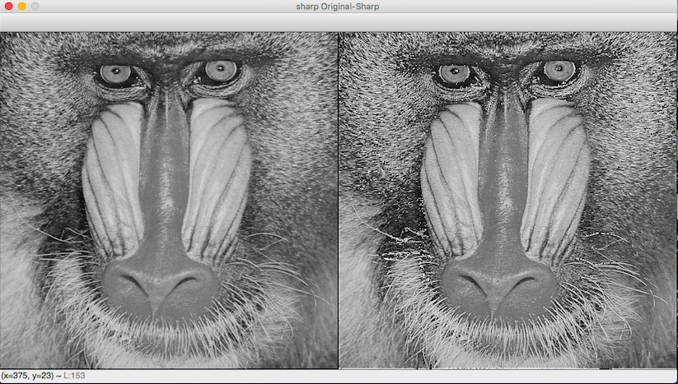

Sharp Image4

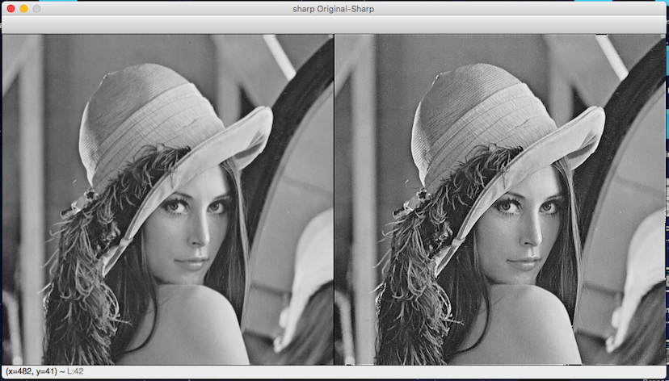

Sharp Image5

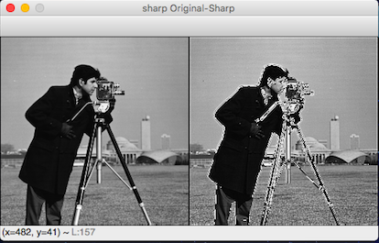

1. Finally, I removed salt and pepper noise by using median filter.

